Download PAC-MCU Str710

1. Connect Device

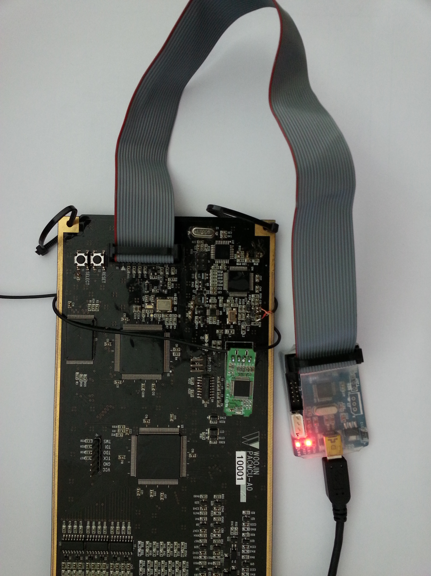
miniJLINK V2.0
PAC JTAG Connect

2. Run J-Flash ARM.EXE Program
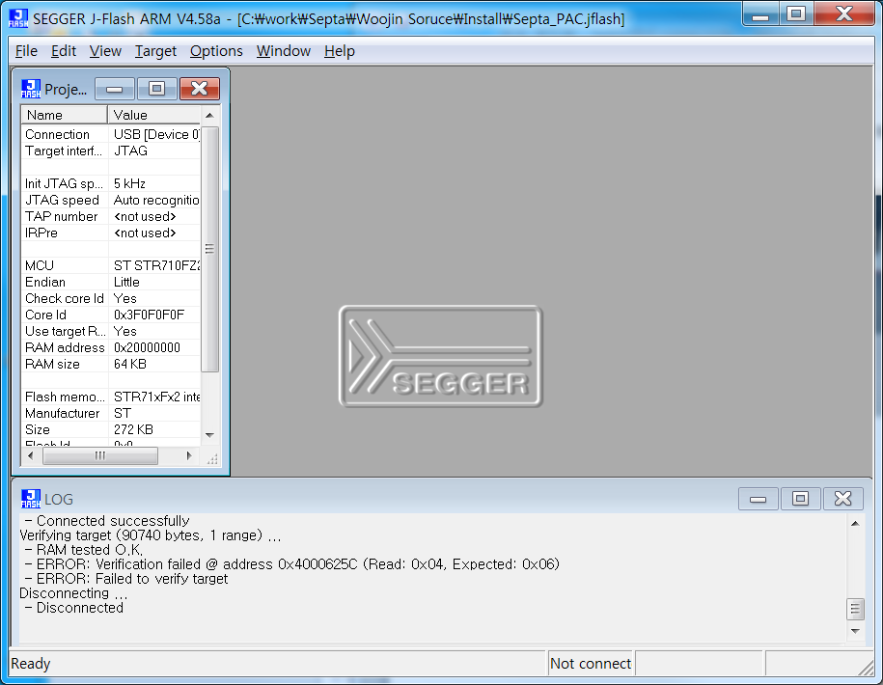
3. Open project : Septa_PAC.jflash open
- File\Open project..(Denver project file은 Septa와 동일하다.)
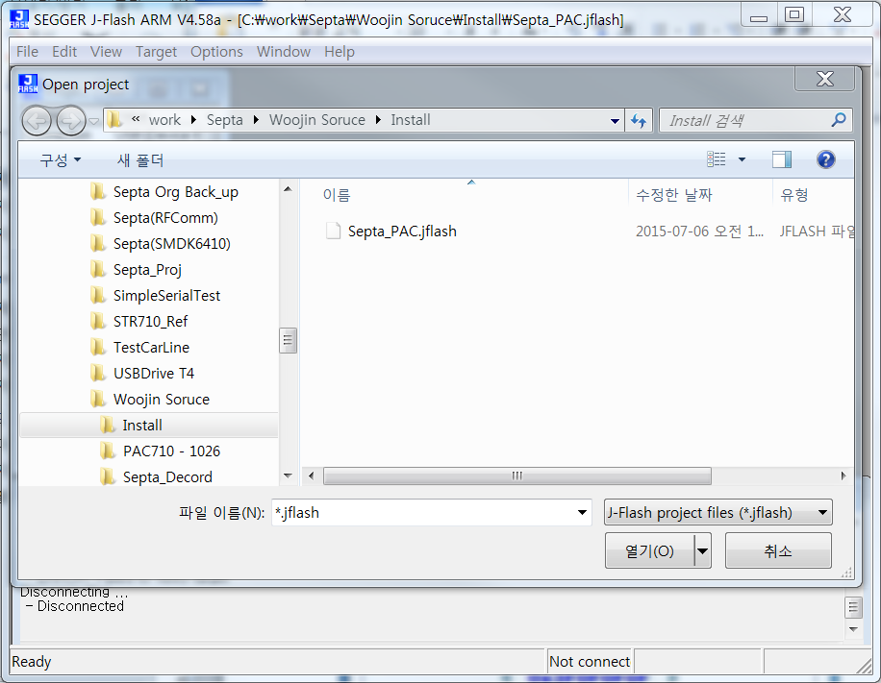

4. Project settings : STR710 download 영역 설정
- Option\Project settings(Sector[2] : Application area)
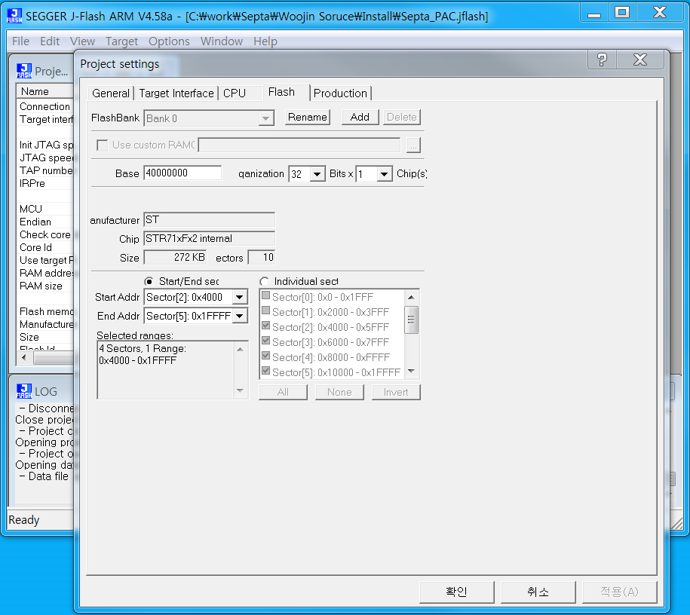

5. Open data file & Start address setting
- File\Open data file\PAC_1026_1500706.bin(Denver binary file로 대체한다.)
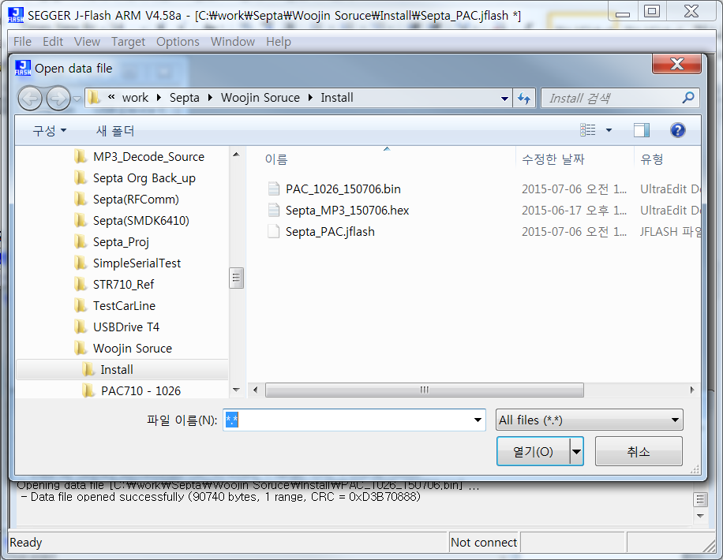
- Start address setting(0x40004000)
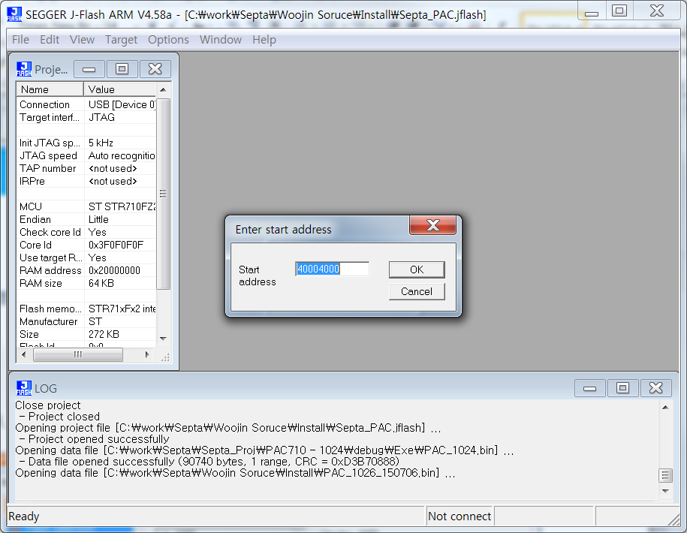

6 PAC program : Connect and Program
- Target\Connect
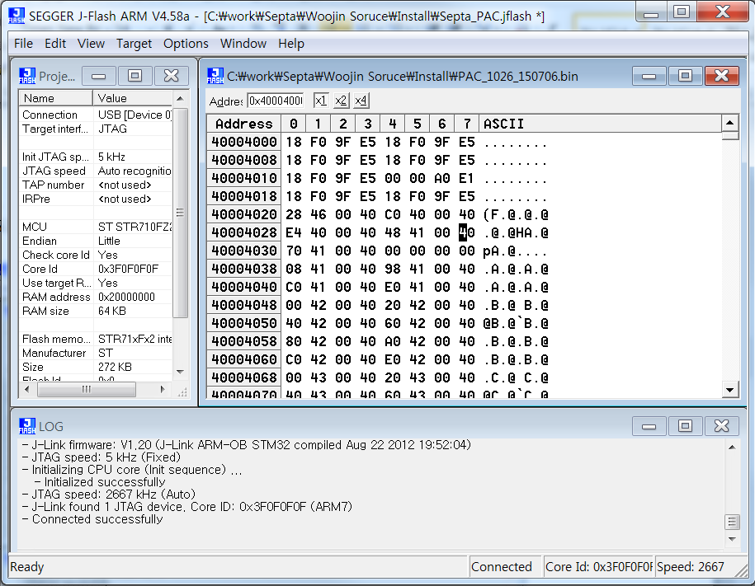
- Target\Program(F5)
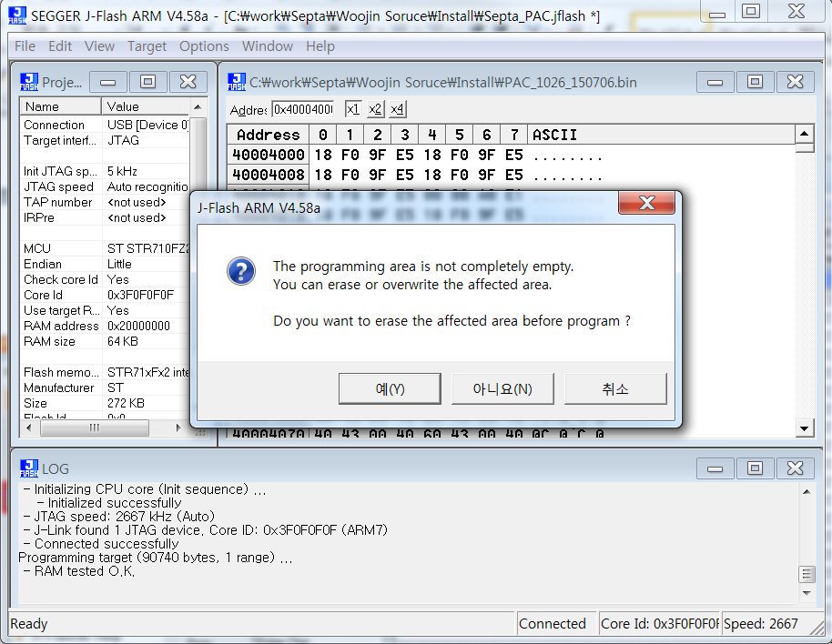

7. Download complete
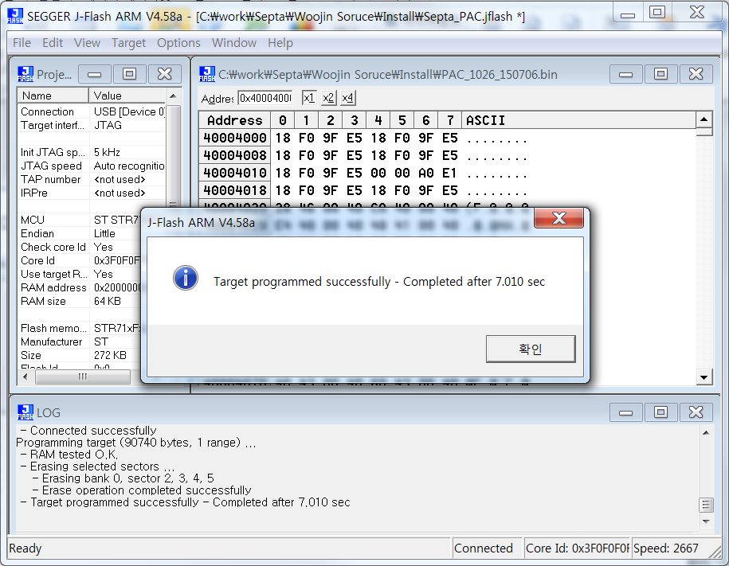

- Boot code download
1. Project setting : boot area 설정.
- Options\Project setting
- Boot code area Sector[0] 선택.
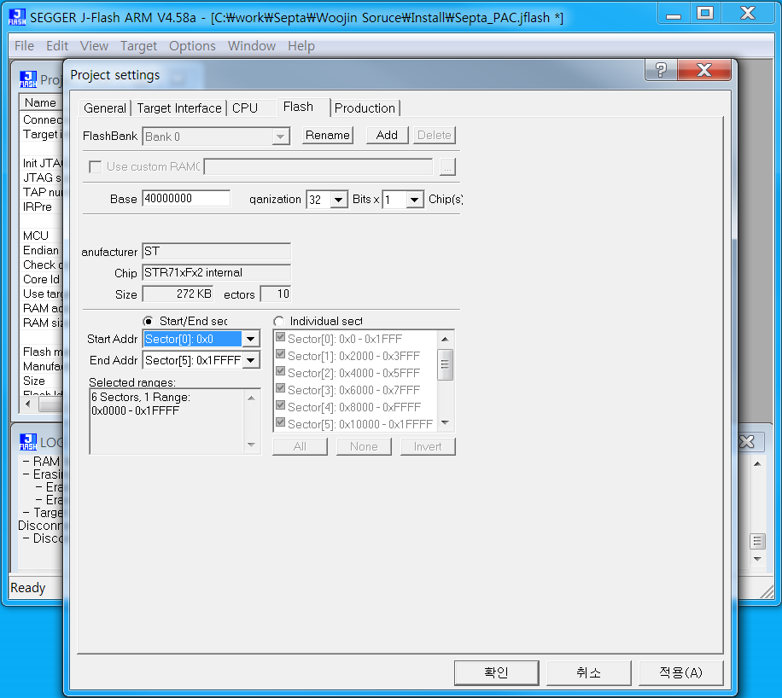

2. Open data file and Start address 설정.
- File\Open data file\Initial.bin(Septa binary file과 동일하다.)
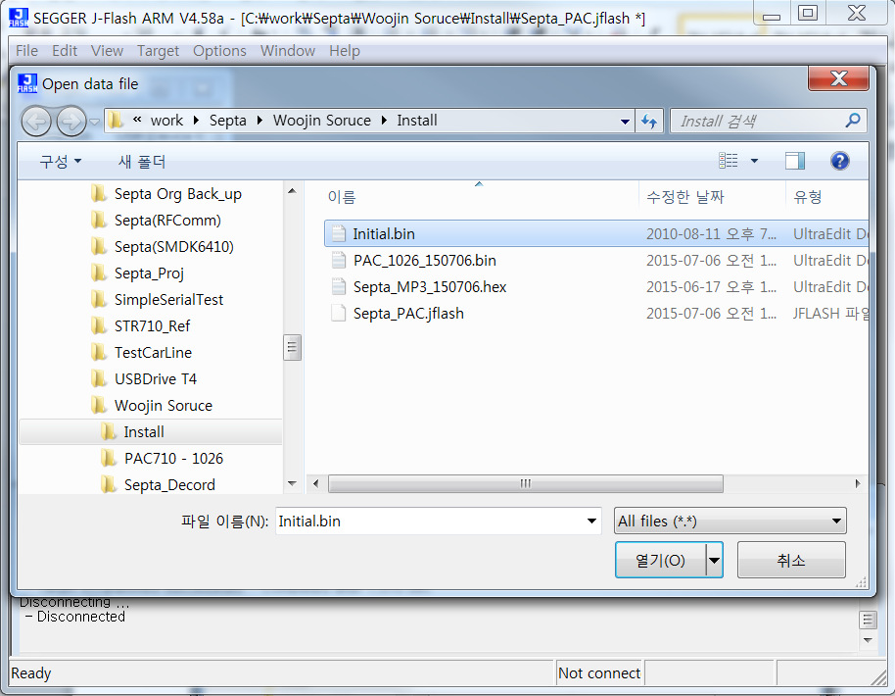
- Start address setting(0x40000000)
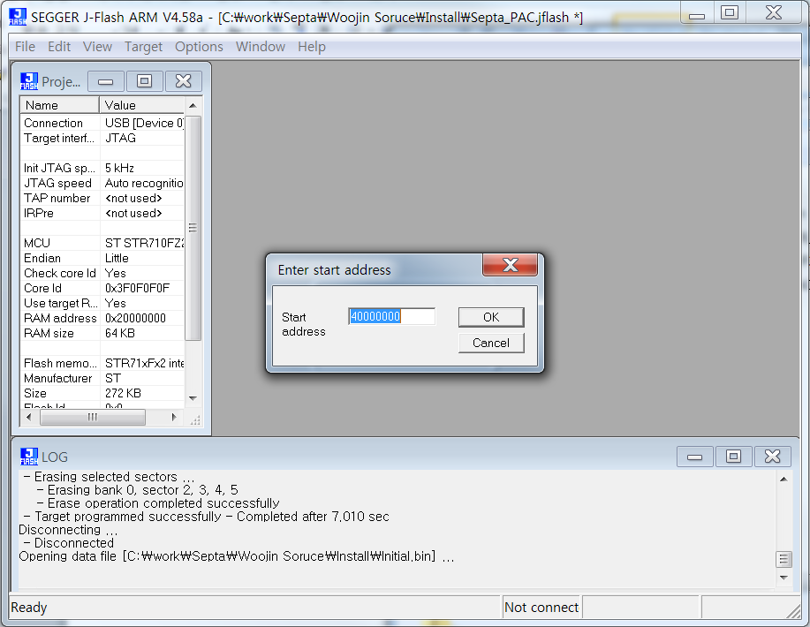

3. Program : Connect and Program
- Target\Connect
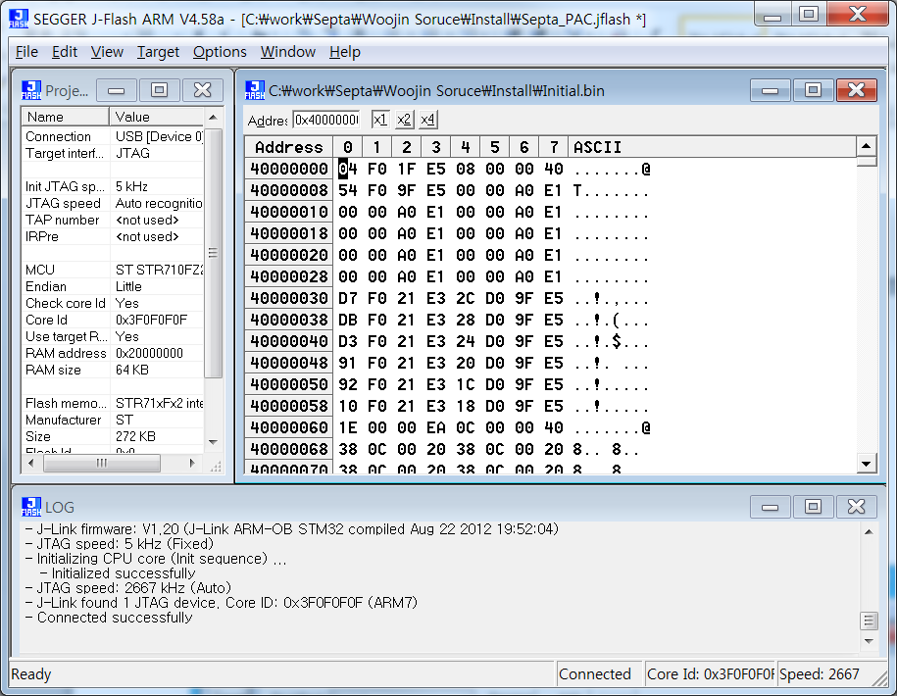
- Target\Program(F5)
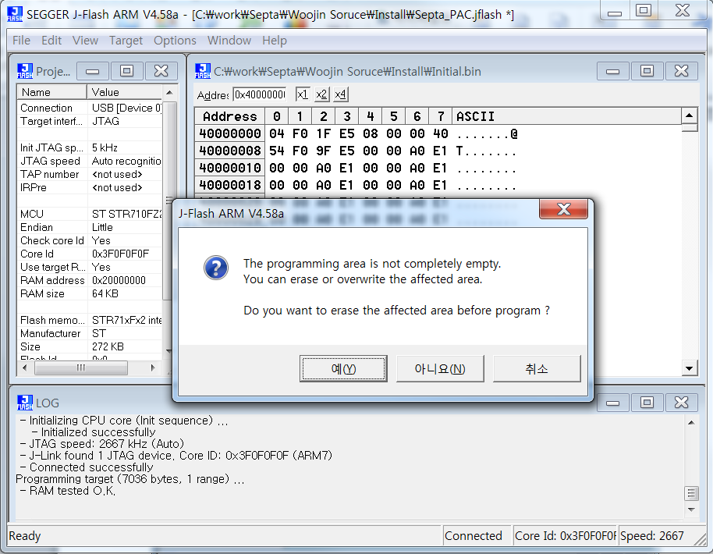

4. Download complete
